# Database model for Event Management Web Application

## User Information

* Added entry in Roles table with ID 1 and Role name as “USER:
* Each user will register with the following details provided in user info table and all registered users will be provided with role called “USER”. (or) all the roles in Roles table.
* User info and Roles are in many-many relationship - Junction table created with each entry of user and roles associated.

Userinfo table –> Username (primary key), Events table - > Event id (primary key)

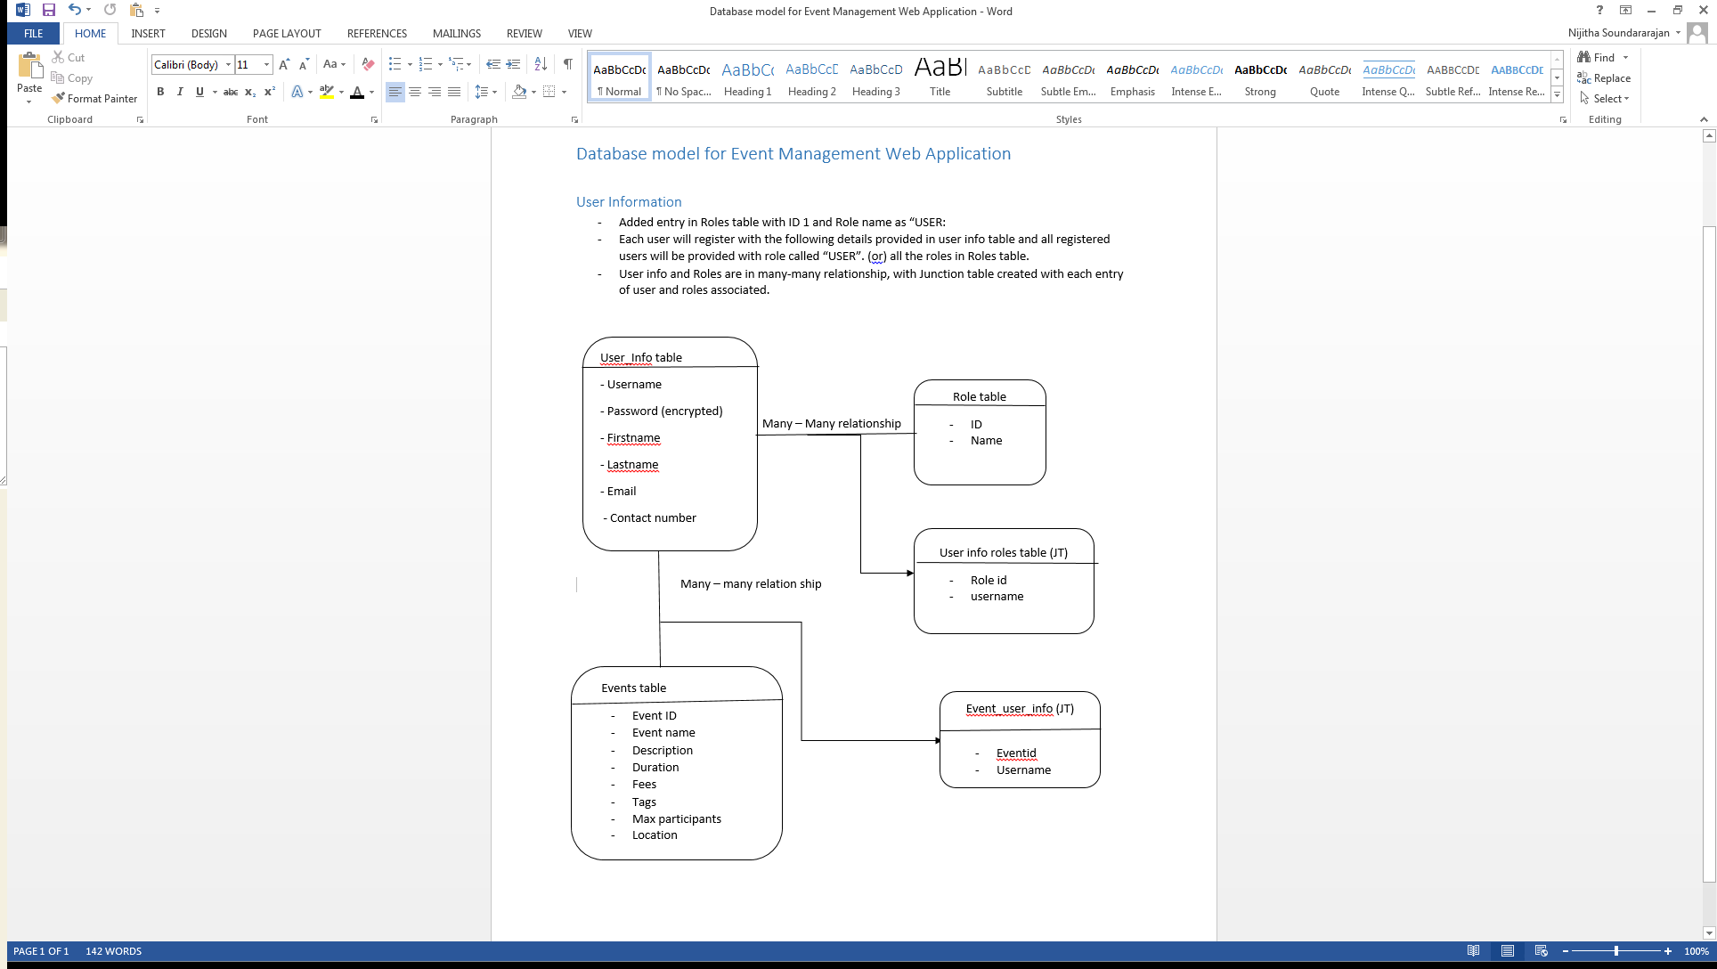

# Event Information

* Events table contains all the necessary information entered by user while created the event.
* Event and user are in many-many relationship
* Each User will contain reference information about events he is part of and each event will contain information about the participants.
* This relationship entry is stored in a junction table called Event_user_Info on registering from a particular event.

# Notification

* When user updates or deletes an event. The notification is saved in Notification table and also, one more table is maintained which contains entries of all user who is part of event
* There is an entry called mark as read. Which is used to set the notification as read instead of deleting the notification of user (can be used later case)
* When user deletes a notification, only his entry will be deleted.
* Maintained separate table for all notification and user notification in two different table for easy maintenance
* Notifcation table can be used as log for later purpose
* For notification, the database model can be enhanced further by creating a relationship (later development)

